

DECKON PREMIUM METAL CEILINGS
CLIP-IN SYSTEM
DATASHEET

Technical Info:

Product : aluminium
Sizes : 300x300mm
Thickness : 0.50mm
Surface : electrostatic powder coated
Perforation : none or ∅1.8-2.5mm hole
Suspension syst : hot dip galvanised steel, black
Edge detail : 20-30mm up-turns, as specified
Fire Resistance : class A as steel
Color : RAL 9010, white

Specification:
Standard clip-in system consists of a concealed supporting structure where demountable tiles can be clipped into the triangular omega main runner. The grid system is not visible. All panels are independently demountable thus enabling easy and fast access to the ceiling void.
VISUAL
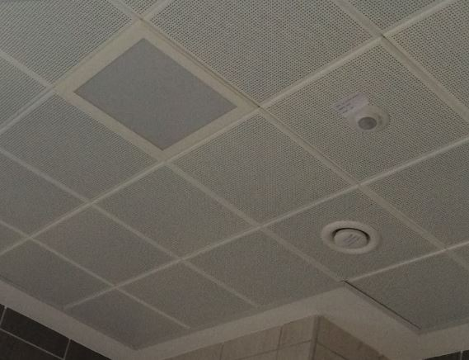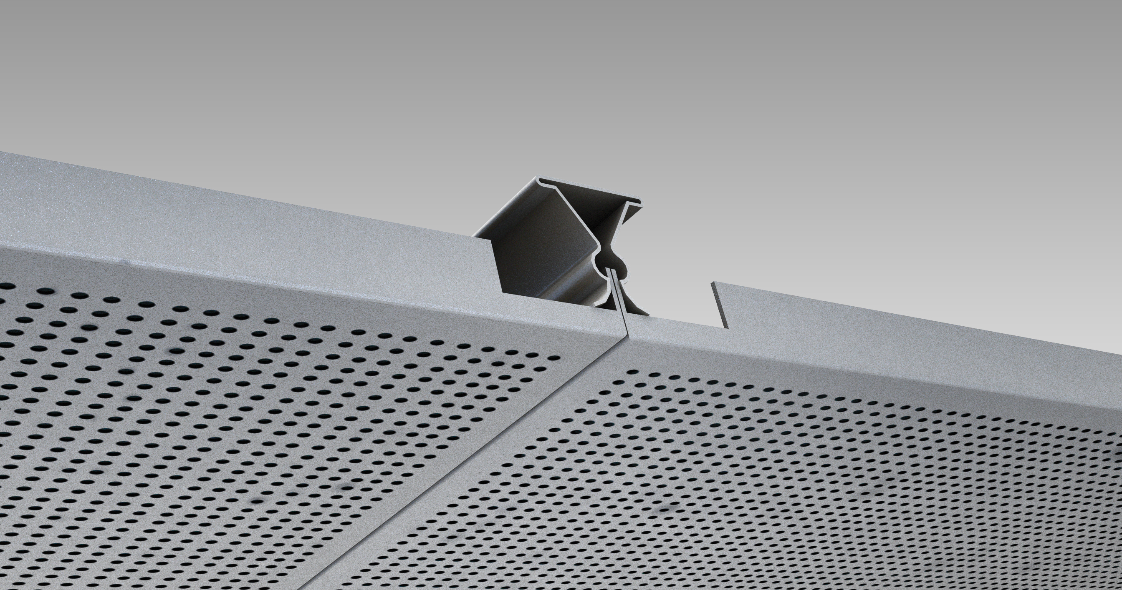

TECHNICAL DRAWINGS
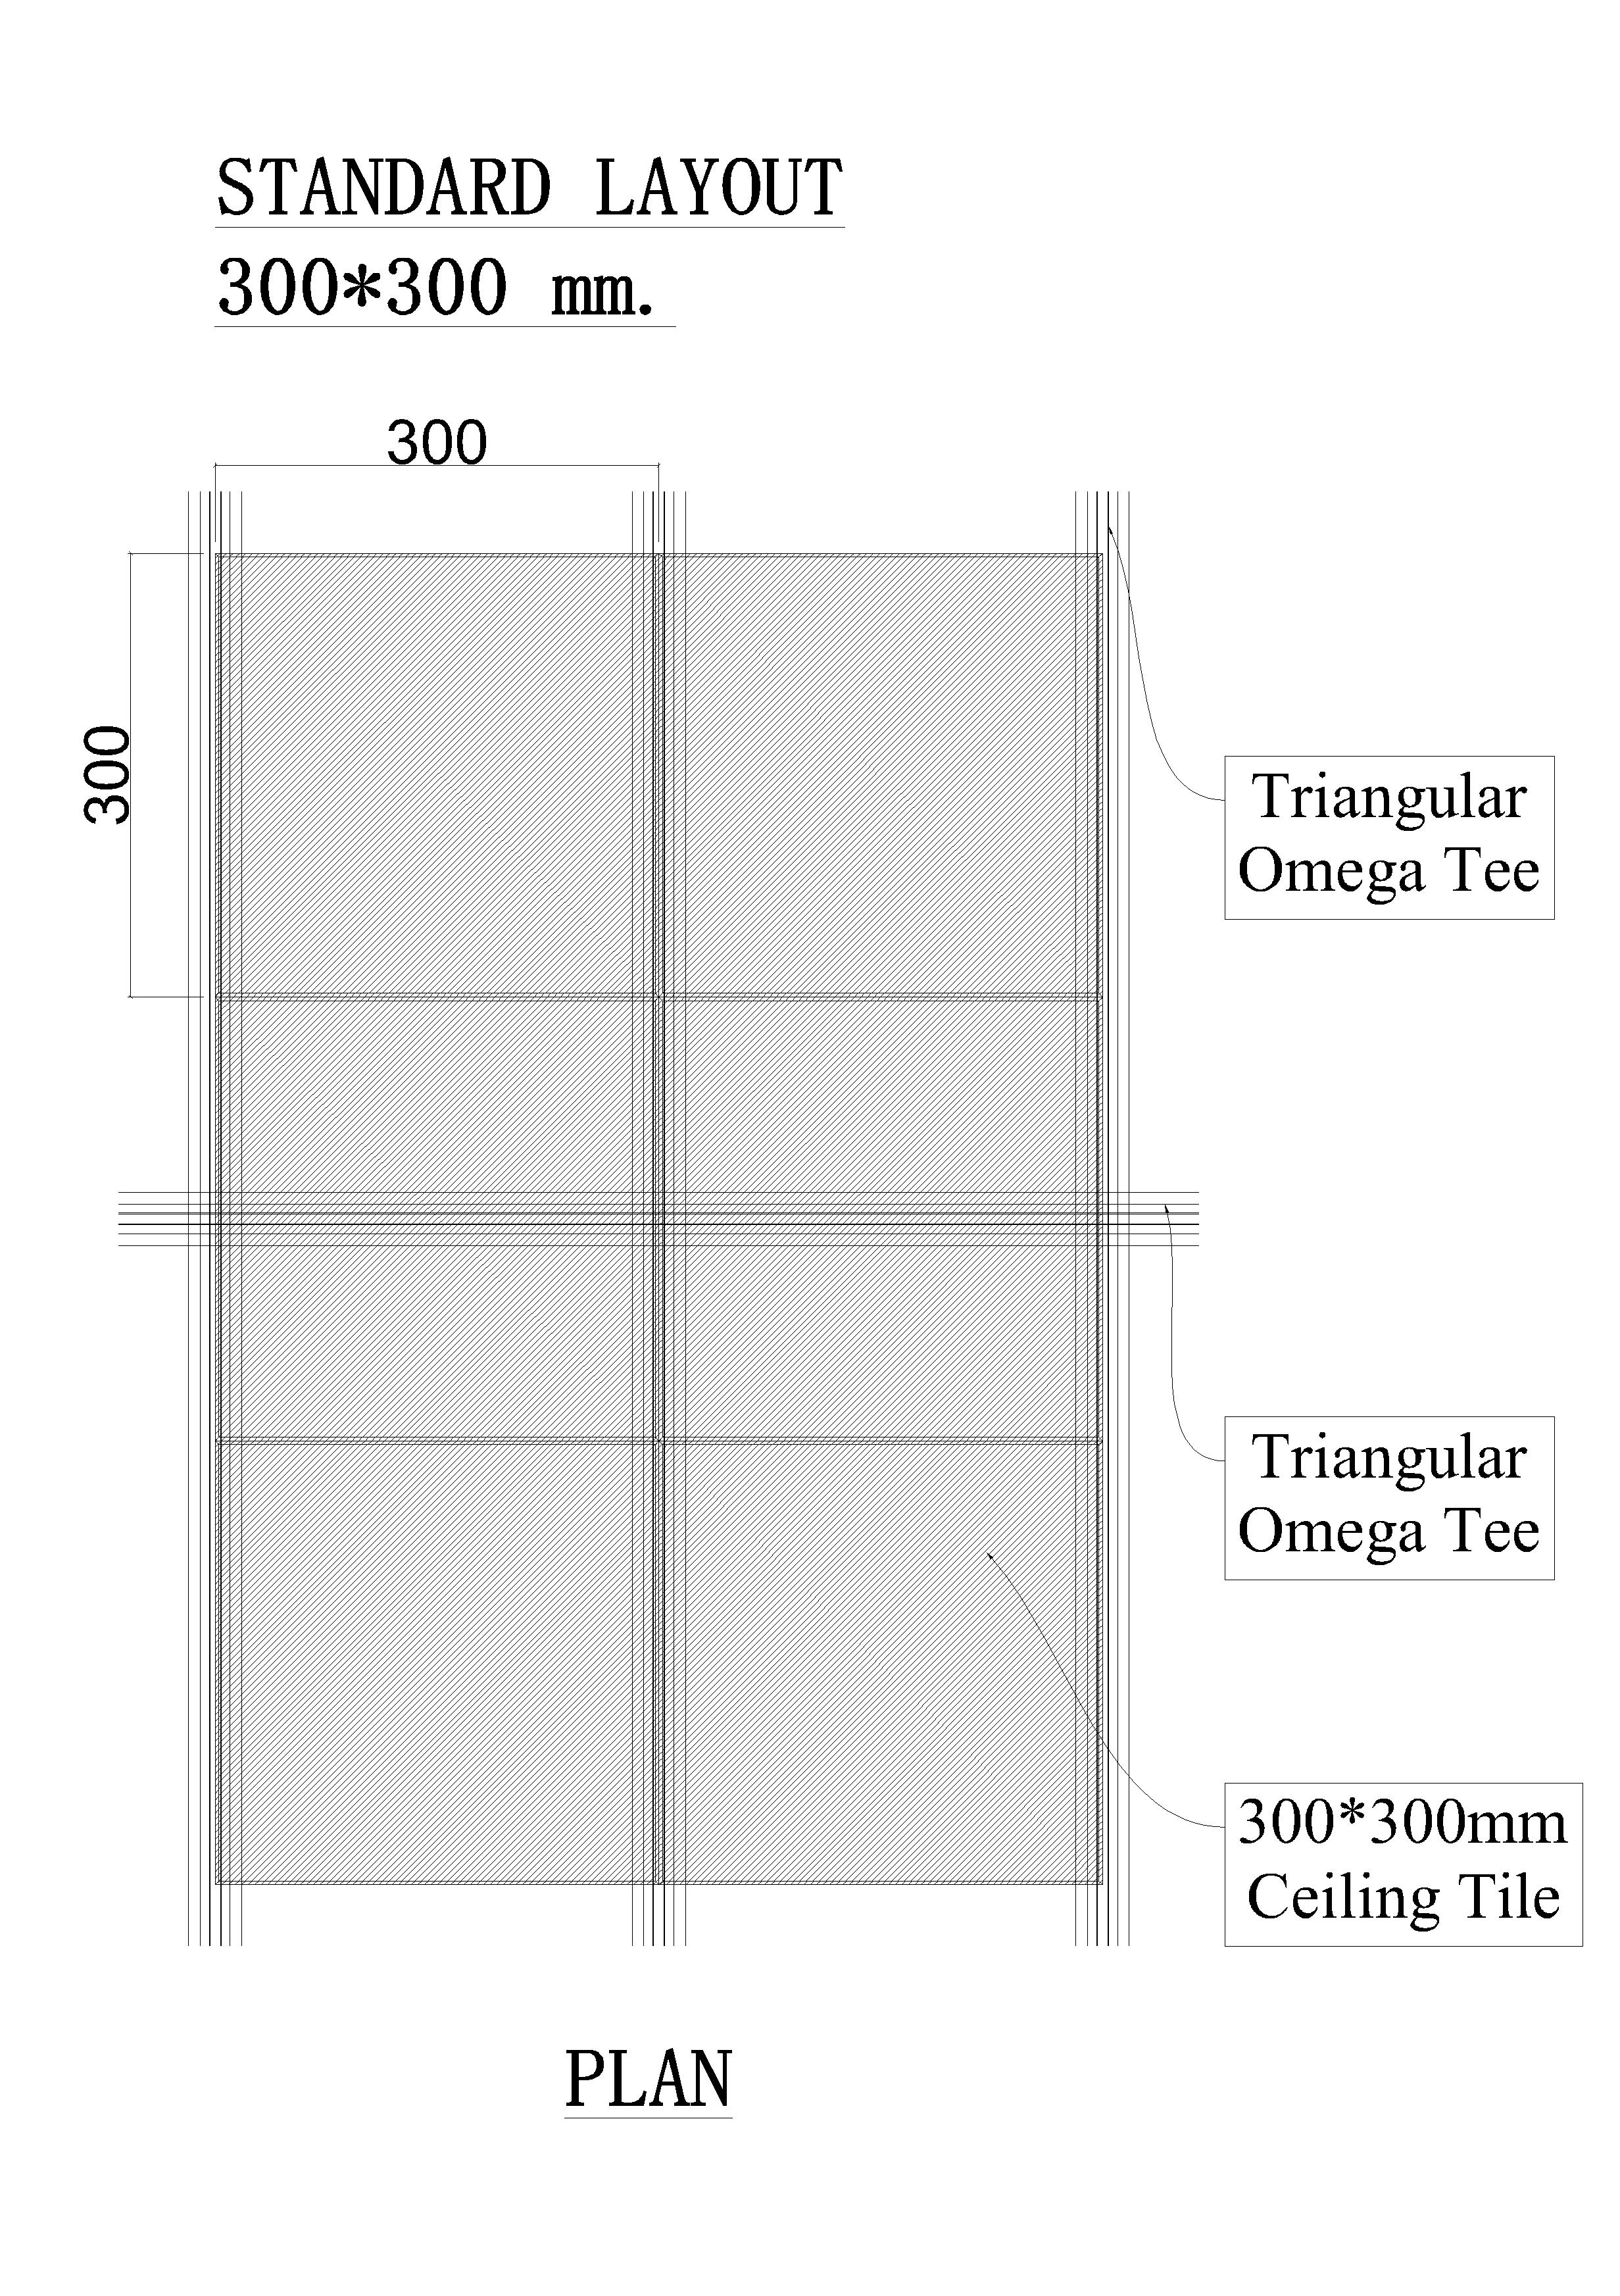
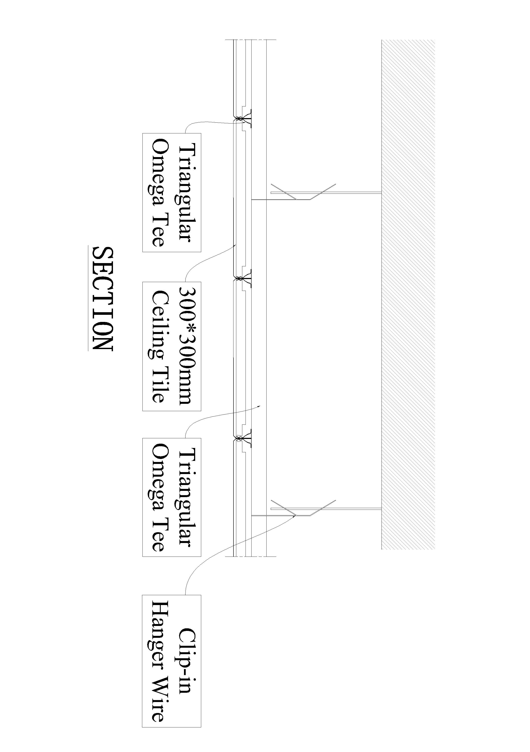

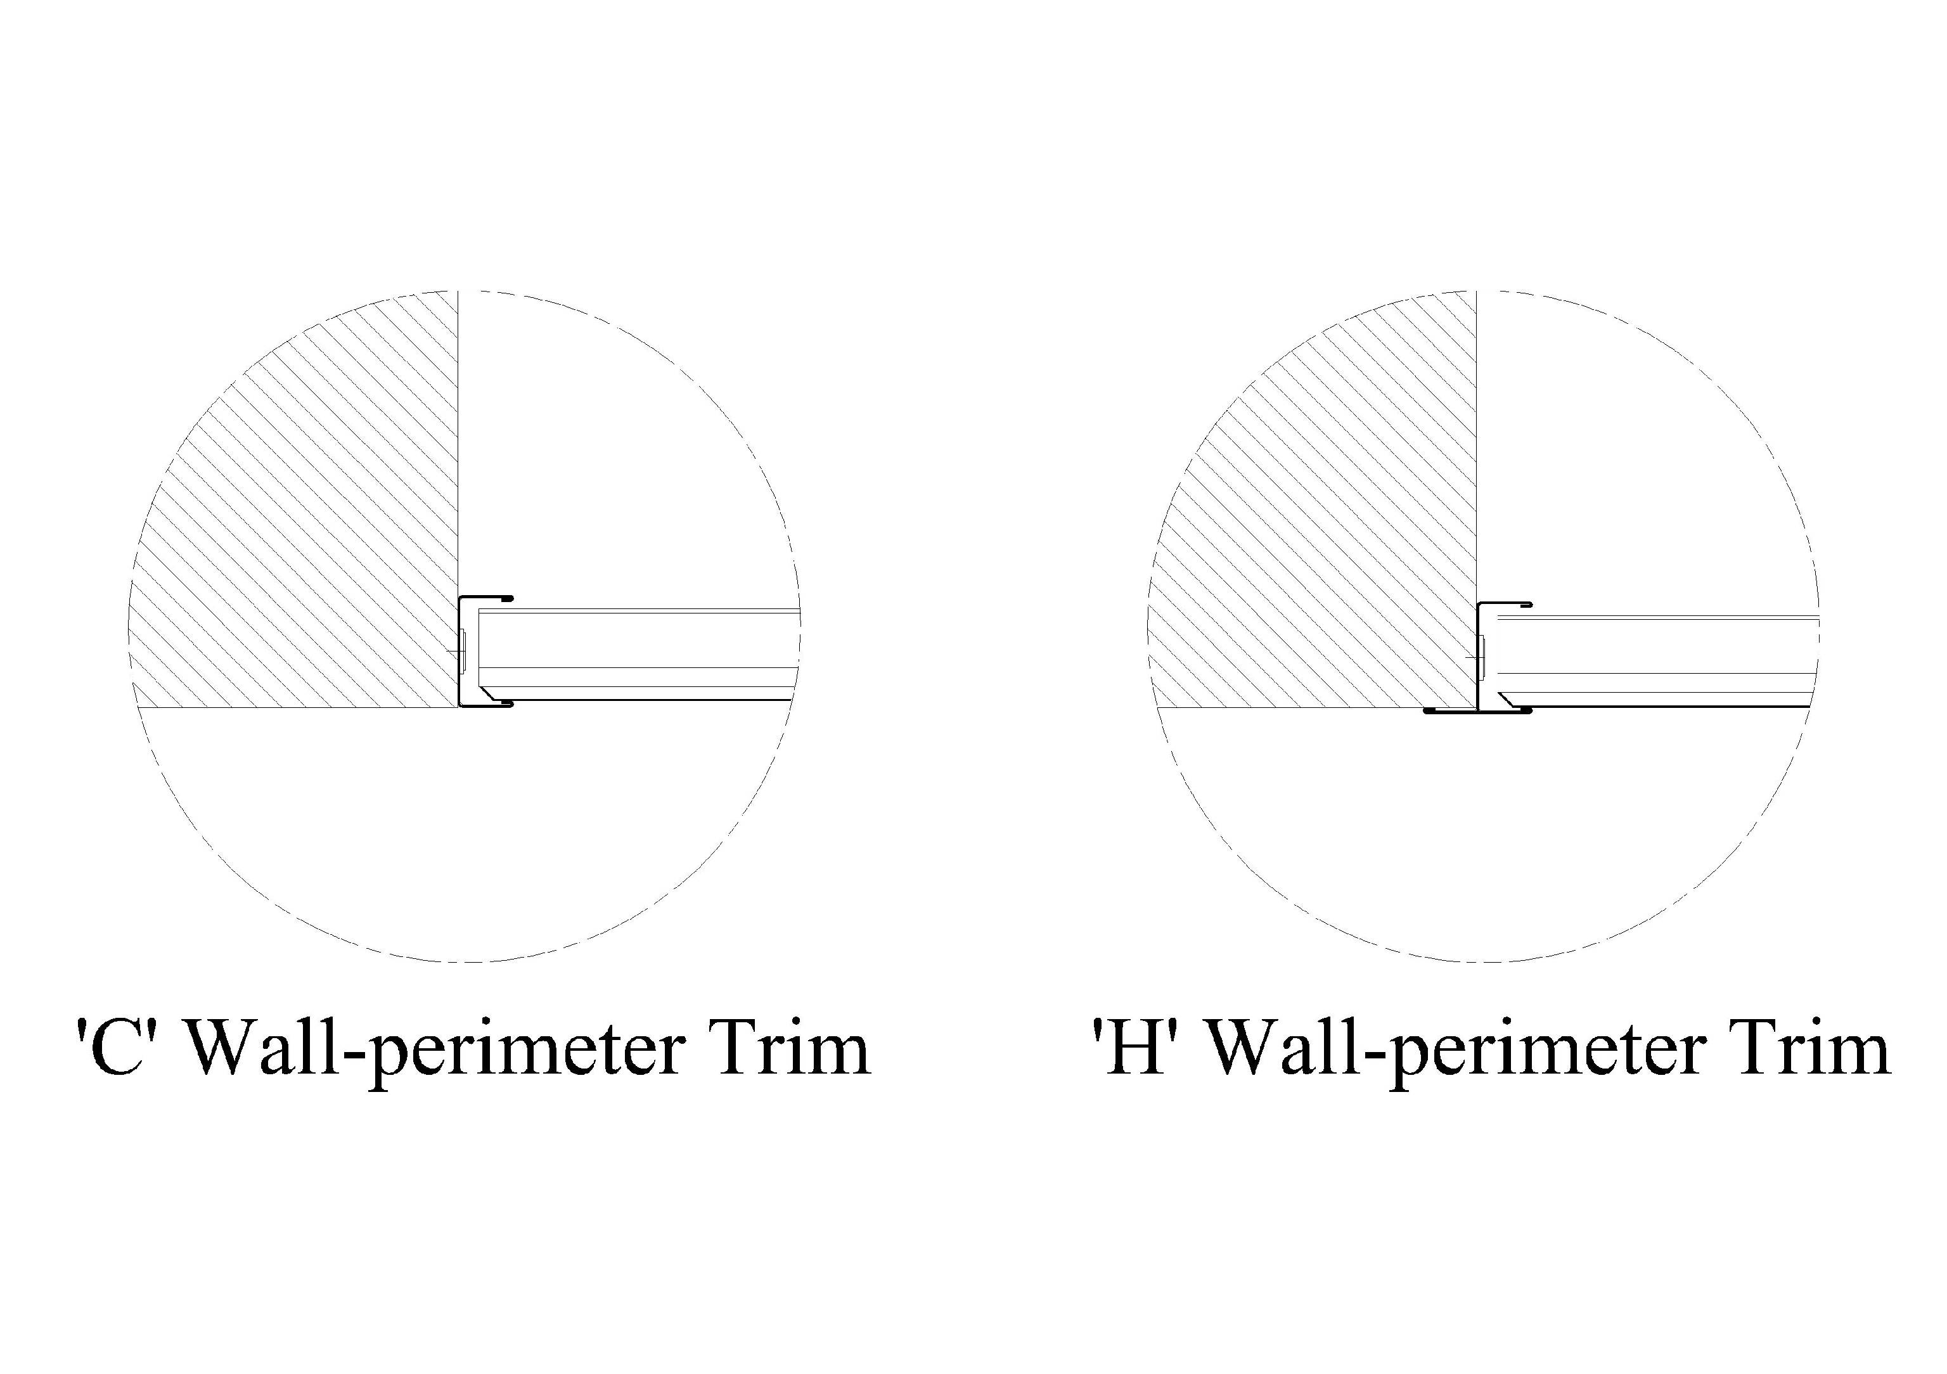
PERFORATIONS
